Airvistara E-Learning Admin & User Quick Review Bug Report

1. Admin Panel Bugs:
2. Add Cancel button in “Add Certification”.
3. Add Cancel button in “Edit Certification”.
4. Add Cancel button in “Add Training”.
5. Add Cancel button in “Edit Training”.
6. Change View of Cancel button in “Add Batch” in Onsite batch management.



1. Add Cancel button in “Plan Training” for plan “Online Training”.
2. In Admin panel “Calendar” is pending.
3. Add Cancel button in “Replan Training” in “Onsite Training Management”.
4. “404 Page Not Found” error on “Certification” icon in “Download Certificate Management”.
5. Remove “index.php” in “Individual Training Report” in “Report” session.
6. In “Log” tab 🡪In “Log User List”, if any one click on toggle button asking trainee or trainer information, Confirmation message arrived, to confirm change status of user but “Cancel” button on confirmation message box is not working.
7. Remove “index.php” from web path for Cancel button on “Edit Banner”.
8. Cancel button not working on “Add Banner” form.



1. Edit button on “Trainer Record “ table, should have to open trainer record in editable form with Edit & Cancel button (Currently it showing trainer record in tabular form with Action column).
2. In “Trainer Record” training button showing training name & .pdf file for documentation but this file can’t open (404 Page Not Found Error Message).
3. Remove “index.php” from Lesson🡪View🡪View .pdf file for lesson.
4. Cancel button on “Add Lesson” form not working.
5. On “Admin” icon dropdown list “Status Calendar” pending.
6. On “Admin” icon dropdown list “Onsite Calendar” pending.
7. In “Notification” showing message for “12 pending notification” but not showing notification in list & when click on “View All” button “404 Error” showing.
8. Remove “index.php” from everywhere in user panel.
9. Cancel button of Add User or Edit user diirecting user for all statestic of user management i.e. internal user as well as external users which leads wrong output, should have to show only internal user or external users (Not combine data)



1. While adding new internal user .....It not taking numerical values (i.e. for test1, it takes only test as user name), But we can edit this user name & while editing it takes numerical values like test1, test2 etc.
2. On Dated 7th Oct 2019 when I add new 10 user as per discussion with Trupti Mam & edit user it show me form like

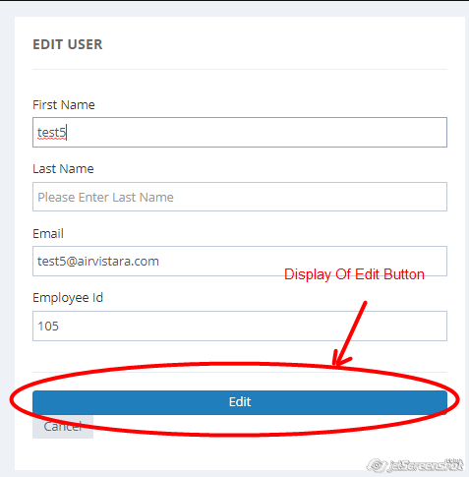

And when I test it today it is looking like this,



Please check for changes. (On Edit user form “Edit” button should be there not “Add” button).